.

23

**FULL ADDER**

**EXP.NO: 23**

**AIM:**

To design and implement the full adder using

Logisim

simulator.

**PROCEDURE:**

1)

Pick and place the necessary gates.

2)

Insert 3 inputs into the canvas.

3)

Connect the inputs to the XOR gate, AND gate and OR gate.

4)

Insert 2 outputs into the canvas.

5)

Make the connections using the connecting wires.

6)

Verify the truth table.

**TRUTH TABLE:**

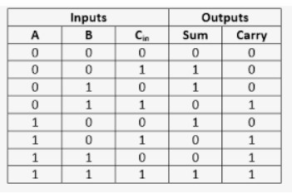

|  |  |  |  |  |  |  |
| --- | --- | --- | --- | --- | --- | --- |
| Sum=(A | ⊕ | B) | ⊕ | Cin | | |
| Carry=A.B+ (A | | | | | ⊕ | B) | |

Logical Diagram:

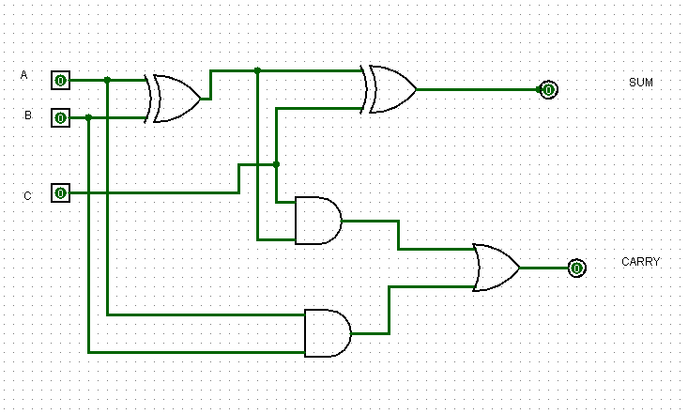

Full adder using NAND Gates:

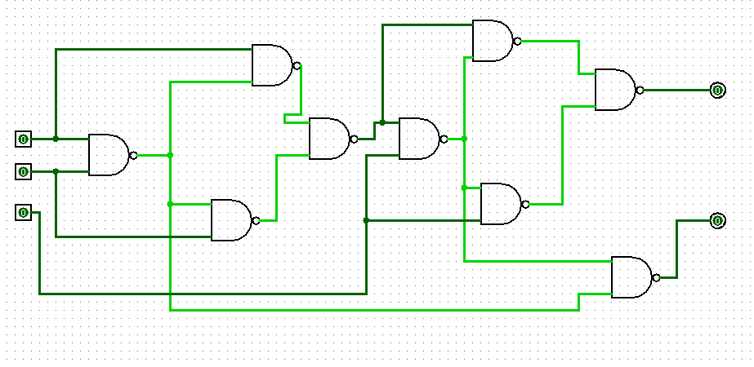

|  |  |  |
| --- | --- | --- |
| Full adder using | NOR | Gates: |

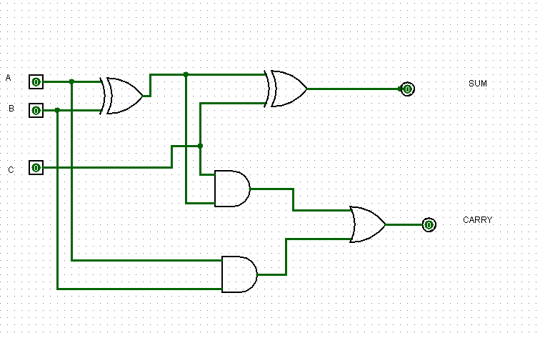

|  |  |  |
| --- | --- | --- |
| OUTPUT  **RESULT:** | Thus full adder has been designed and implemented successfully using | logiism |
| simulator. |  | |